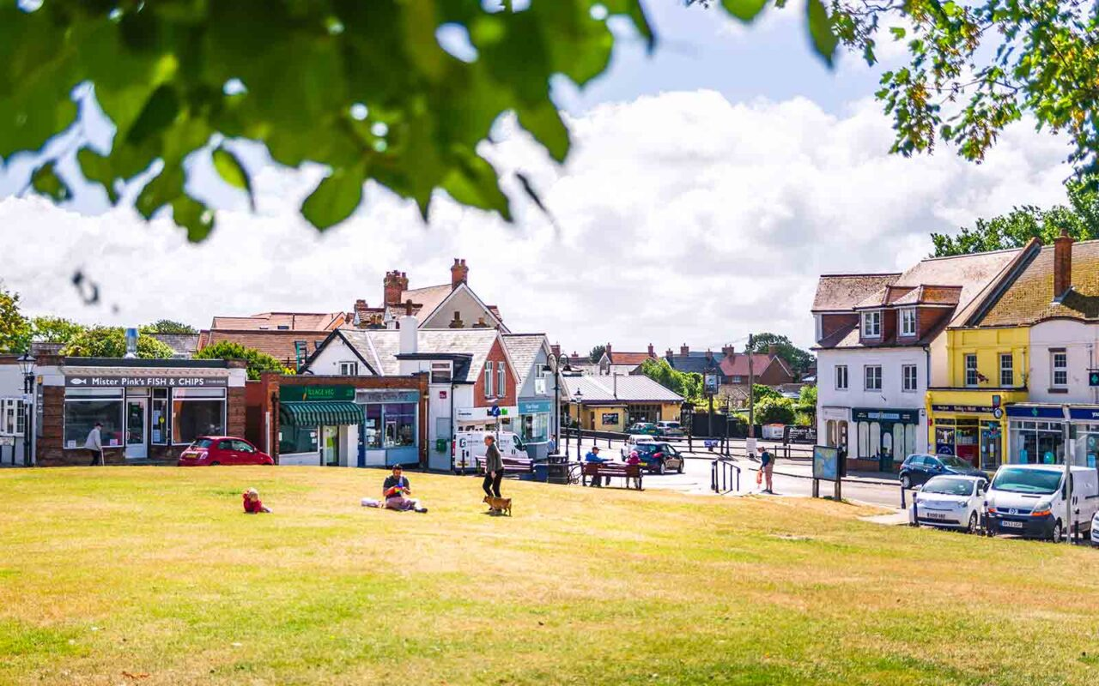
Parish Council’s Annual Report 2025 - 26
Milford-on-Sea Parish Council
22 High Street, Milford-on-Sea,
SO41 0QD. www.milfordonseaparishcouncil.gov.uk
01590 644410

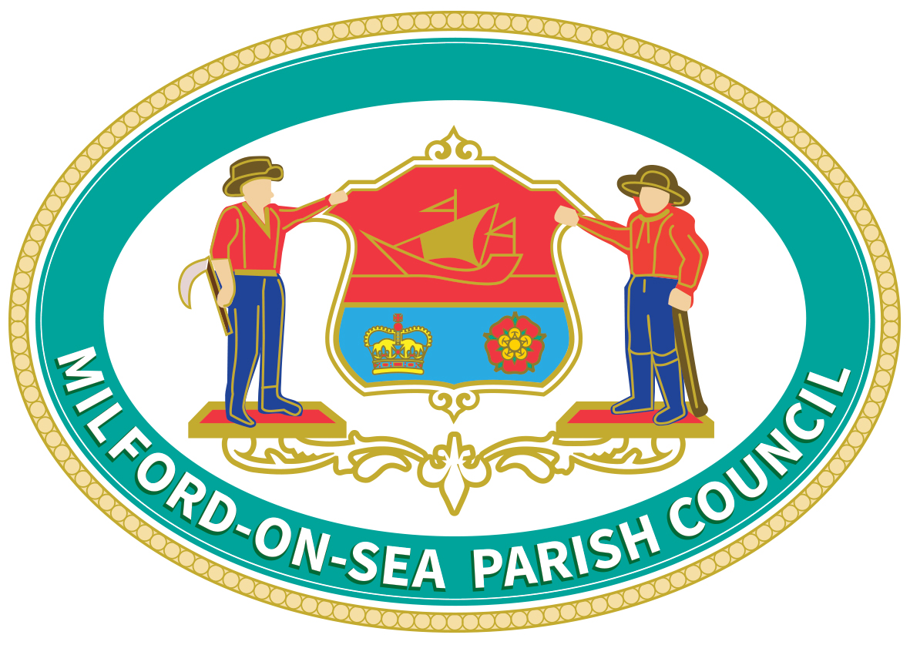
The Parish Council is the custodian of land/property owned on behalf of its community.
- The Pleasure Grounds – Local Nature Reserve
- Sharvells Copse (Shorefield’s Copse) – Local Nature Reserve
- Barnes Copse – Local Nature Reserve
- Studland Common – Local Nature Reserve and Site of Importance for Nature Conservation (SINC)
- Studland Common Grazing Field – Local Nature Reserve and SINC
- Scholars Retreat Grazing Field
- Tony Locke Community Orchard
- Barnes Lane Recreation Ground and Chris Walford Pavilion
- Carrington Lane Play Park
- The Swifts Play Park
- Hurst Road Play Park
- Allotments at The Swifts
- Swallow Drive/Grebe Close Public Open Spaces
- The Centenary Copse (next to Milford Bridge)
- Baskets Grazing Field (Keyhaven)
- The Community Meadow (Next to All Saints Churchyard)
- The Old Putting Green (Hurst Road)
- The Village Greens at both Keyhaven and Milford-on-Sea
- The Bowling Club Green and Pavilion (The Bowling Club now maintain and manage the facility)
- Dance Studio in Sea Road Car Park (Managed by the VCCC)
- Bird Hide at Sturt Pond Nature Reserve (Managed by Milford Conservation Volunteers)

The Parish Council maintain all the above land and property. The land at Hurst Road and the Centenary Copse are owned by the District Council but leased to the Parish Council who maintain them.

The Parish Council Planning Committee makes valuable observations to the local planning authority (New Forest District Council and the National Park Authority), on every single planning application and all tree works orders for
the Parish, which are considered by the relevant bodies when making their final decisions.

The Parish Council employs a full time Parish Clerk, and a part time Assistant/Planning Clerk for 20 hours per week.

Producing the annual budget takes several months (including several working group meetings) and is then passed through to the Full Parish Council Meeting, which is open to the public and to which residents are invited to attend and contribute to the process under a Public Participation Scheme (details of which are available from the Parish Office).

The annual operational expenditure budget for 2025/26 was £250,143. To meet the budget, the Parish Council needed a precept of £239,400 (the amount requested from New Forest District Council) this represented an increase of £5.91 per household per year (Band D) 8.1%.

2026/27
Due to some internal restructuring in 2025 the Parish Councils operational expenditure is not expected to increase significantly and has been set at £257,527 (the national pay award is currently unknown).
However, when the Internal and External Auditor reviewed the Parish Councils accounts, they both recommended that all Town and Parish Councils should hold reserves between 3-12 months of expenditure (as also suggested in the Practitioners Guide for 2025). Historically Milford-on-Sea Parish Council has held less than one month’s expenditure in reserve. Therefore, the Council has agreed to hold the minimum recommended of 3 months expenditure in reserve for 2026/27. To meet this requirement the Parish Council needs a precept of £298,634, this represents an increase of £15.40 per household per year (Band D) 19.5%.
Employment: 2024/25 2025/26 2026/27
Salaries £109,994 £77,773 £71,432
National Insurance and Pensions. £34,764 £26,059 £23,073

Property:
Rent, Rates, Insurance and Utilities. £19,101 £19,150 £18,050

Administration:
Newsletters, Telephone & Broadband, Travel, £14,500 £17,350 £17,500
Stationary, Photocopying, Training & Audits.

Youth & Community Support:
Youth Grant, Support Grants, Community Centre Loan. £16,472 £17,972 £20,472

General Maintenance:
Waste Bin Collection, Fuel, Benches, Christmas Lights . £13,400 £19,854 £22,200

Sports & Play Parks:
Recreation Ground, Sea Front, Carrington Lane, The Swifts. £ 4,150 £ 5,100 £ 9,950

Planting Projects:
Community Meadow, Hanging Baskets, £ 4,989 £ 9,150 £ 4,500
Tony Locke Orchard & Additional Small Projects.

Land Maintenance:
Grass Cutting and Strimming, Woodland/Common £ 9,000 £57,735 £70,350
Management, Forest Paths, Hedges
Tree Surveys & Work, HLS Maintenance & River Revetment.

Totals £226,279 £250,143 £257,527

Capital Expenditure:
CIL carry over from previous year. £ 9,149 £ 15,377 £ 1,476
CIL received. £ 12,710 £ 6,315 £ 3,576
CIL expenditure. £ 6,482 £ 20,216

CIL Balance £ 15,377 £ 1,476
Mitigation Funds (Swifts Play Park/Machinery)
MF carry over from previous year. £ 18,713 £ 10,753 £ 15,032
MF received. £ 0 £ 17,500
MF expenditure. £ 7,960 £ 13,221

MF Balance £ 10,753 £ 15,032

Parish Council Achievements in Partnership with Village Groups, for 2025/2026

- Natural England Higher Level Stewardship grazing agreement continues with the clearing of several scrub sections at Studland Common.
- Programme to manage the Upper & Lower Pleasure Grounds.
- Revetment Work to the Danestream
- Further Planting and Landscaping at the Community Meadow
- Reduction of all Parish Owned Hedges to 4.5ft in height.
- Continued upgrade of footpaths, culverts, bridges ditches and revetments in the Upper and Lower Pleasure Grounds.
- Continuing to upgrade and repair benches along the Cliff Top, Keyhaven and the Village Centre.
- Extension of a wooden fence at Barnes Lane Recreation Ground
- Larger Waste Bins on Parish Land
- New Play Equipment at Carrington Lane Play Park (replacing rotten units)
- Additional Benches on Studland Common and Meadow
- Upgrade of Parish Council Website

Projects planned for 2026/27 (Subject to finance and agreement)
- Review of crumbling benches along the Coastal Path
- Upgrade of some Play Equipment at Hurst Road Play Park
Volunteers help extensively around the village in many ways. They spend hundreds of hours of their own time
each year supporting the Council and enhancing community facilities. The Parish Council welcomes this
support, which benefits the wider community and thanks those that give so much of their time so freely to the
village.

The Parish Newsletter is in the bi-monthly Village Voice and on our website www.milfordonseaparishcouncil.gov.uk
Contact us:

Telephone 01590 644410
Email clerk@milfordonseaparishcouncil.gov.uk
Letter to The Parish Office, 22 High Street, Milford-on-Sea, SO41 0QD

Opening Hours: 10am – 12pm and 1pm -3pm (Monday to Friday)

Residents are welcome to attend all parish council meetings which are held in the Village Hall and may address the committees in the public participation sections.

Notice is required if you wish to speak at a public meeting via the Parish Office. A maximum of 3 minutes is allowed under public participation.

Details of Parish and Planning Committee Meeting are on the Website and on Village Notice Boards.

